**Cryptography and Network Security Lab 4**

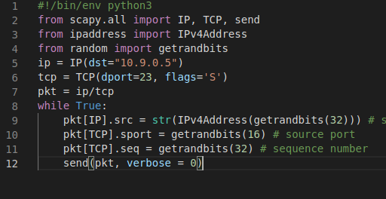**Task 1**:

Changing IP, TCP details

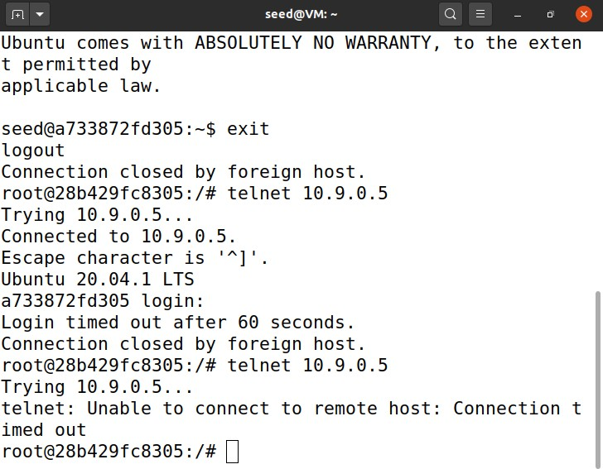Task 1.1

Connection timed out.

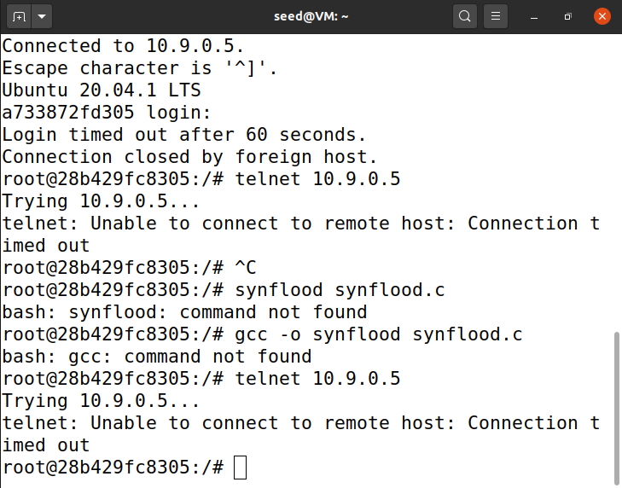Task 1.2

Using C program, connection timed out

Task 1.3:

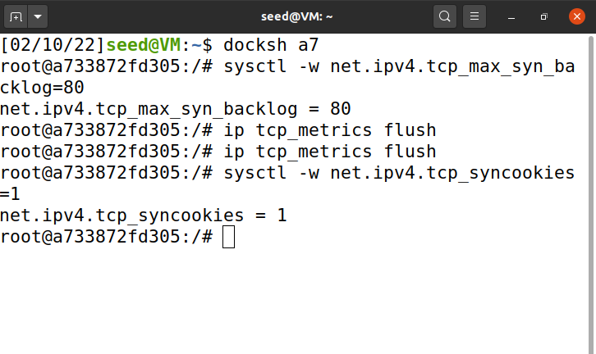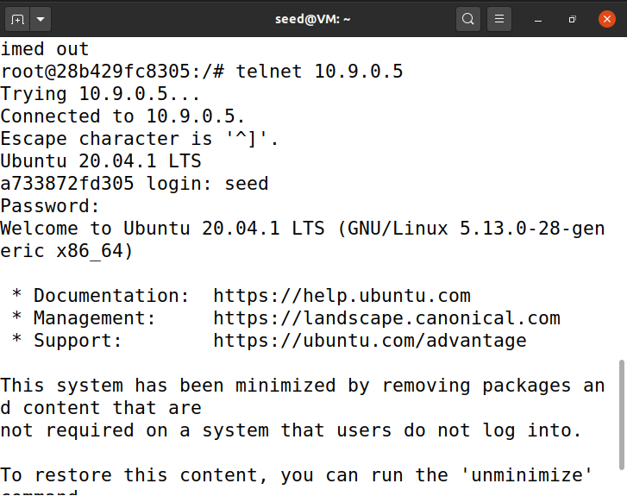

Enabling SYN cookie

Connection established

# Task 2:

Launching the attack manually.

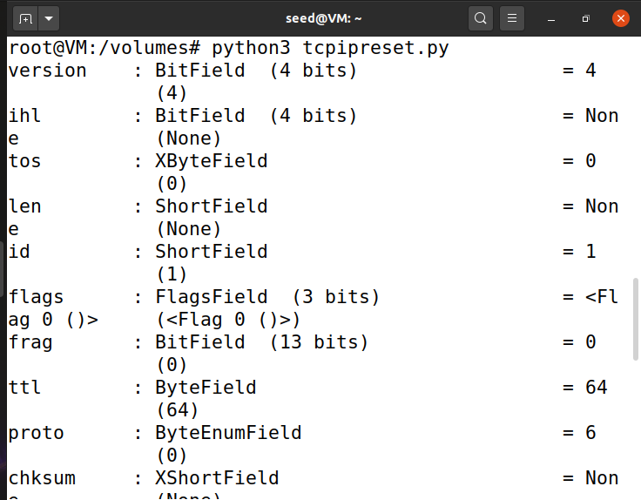The python code is run under attacker.

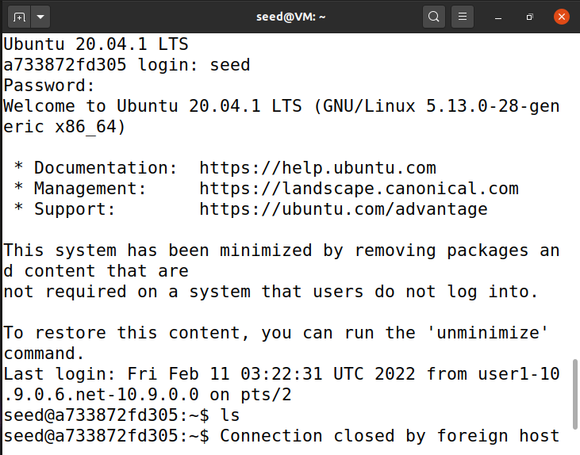The connection is closed by foreign host.

# Task 3:

Python code :

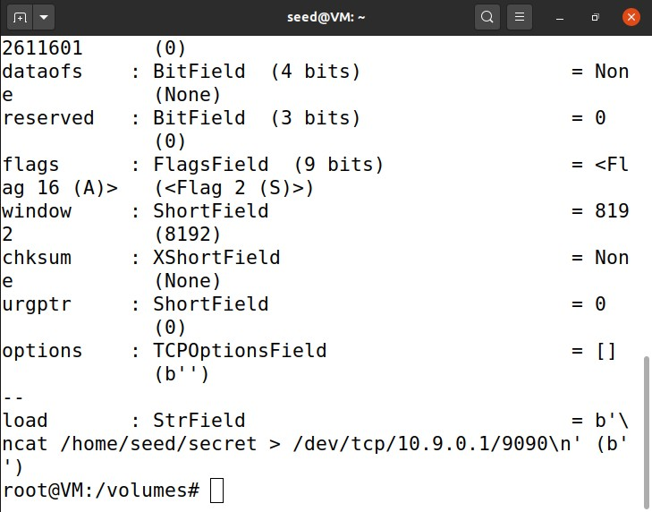Code executed under attacker:

Connection established and the secret message is also displayed.

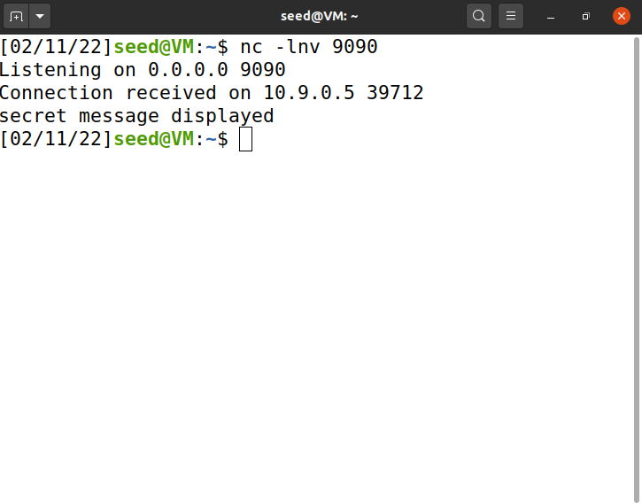

# Task 4:

Code in python:

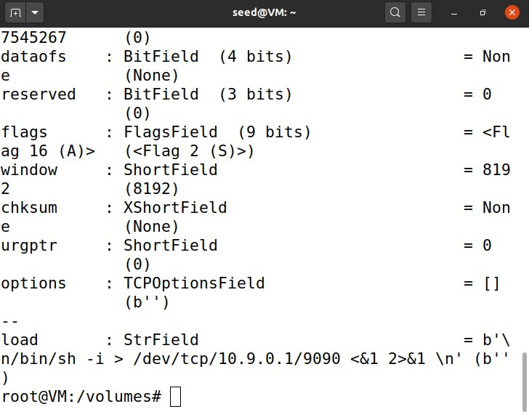code executed under attacker.

Connection is established and reverse shell is executed.

